**Palladium**

**Summary**

New York’s Palladium Ballroom is commonly revered as the birthplace of modern Latin dancing. Known as ‘the home of the mambo’, the Palladium was New York’s most popular venue for Latin dance music from 1947–1966. It featured live Latin music four nights a week, frequently played by ‘The Big Three’ orchestras––Machito and his Afrocubans, Tito Puente, and Tito Rodríguez. Located near prominent nightclubs and theatres at 53rd St. and Broadway, the Palladium was significant for bringing Latin music to midtown Manhattan and for the racial and ethnic integration it engendered. Puerto Rican, Cuban, Italian, African-American, Irish, and Jewish patrons of all classes filled its dance floors where they rubbed elbows with celebrities who frequented the dance hall, especially on Wednesday nights when ‘Killer Joe’ Piro hosted the popular mambo contest and professional show. The weekly show launched the careers of many dance teams who then performed in Catskill and Miami Beach resorts and worked as opening acts with touring musicians. Mambo was the favorite dance of Palladium regulars, but other dances experienced surges of popularity, including cha cha cha (1954) and pachanga (1961).

**Beginnings**

The second-story dance hall at 1698 Broadway was struggling to turn a profit with its regular fare of American music (e.g., waltz, foxtrot, swing) when manager Tommy Morton approached Machito’s musical director Mario Bauzá for assistance. Bauzá asked Morton how he felt about black people, and according legend, Morten quipped that green was his only colour of interest. With the help of promoter Federico Pagani, they organized a Sunday matinee dance featuring six Latin bands (Machito closing the show) and advertised heavily in Harlem and Spanish Harlem. The event, billed as the ‘Blen Blen Club’, drew such a large audience that police were called to control the crowds circling the block. That Sunday dance in 1947 is regarded as the birth of the Palladium Ballroom as a Latin dance institution.[1] Within a year, the ballroom exclusively programmed Latin music.

**Weekly Dance Contest**

The location of the Palladium in midtown was significant because it brought Latin people and their music into the center of racially segregated Manhattan, engendering cultural and ethnic mixing through music and dance. Although the ballroom was also open Friday, Saturday, and Sunday nights, Wednesdays drew the most ethnically and economically diverse crowds due to the appeal of the weekly dance contest and show. The evening began with a dance lesson by ‘Killer Joe’ Piro, an Italian American former lindy hop champion whose refrain of ‘vaya means go’ echoed through the ballroom. Killer Joe also served as master of ceremonies for the weekly amateur mambo dance contest, judged by celebrity guests such as Marlon Brando, Kim Novack, Marlene Dietrich, and Harry Belafonte. Contestants, who were handpicked by Palladium owner Maxwell Hyman, often became performers in the professional show that followed. Favorite dance acts at the Palladium included Augie & Margo Rodríguez; Cuban Pete & Millie Donay; Joe Vega & Tybee Afra; Jackie Danois & Tandelayo; Larry Seldon & Vera Garrett; Mike & Nilda Terrace; Millie Donay & Marilyn Winters; and the Mambo Aces (Aníbal Vázquez & Joe Centeno).

The Palladium’s dance floor was remarkably colour-blind for its day, although many dancers maintained hierarchies based on dance skill and professional status. The best amateurs, some of whom were considered better dancers than the professionals (Luis ‘la Maquina’ Flores, for example), dominated the corner to the right of the bandstand. The professionals danced to the left of the bandstand where they could show off for the wealthy patrons and celebrities who sat at the tables situated nearby. It was on this social dance floor, where patrons from diverse social and ethnic backgrounds copied and stole moves from each other, that many of mambo’s steps were born.

**Legacies**

The Palladium lost its liquor license after a drug raid in April 1961.[2] This crippling event coupled with the rising popularity of rock `n´ roll music eventually forced the ballroom to cease operations in May 1966. Latin music styles developed at the Palladium influenced the future of jazz and rock music, and became the foundation of salsa music of the 1970s. Dance styles and steps born through the collision of cultures meeting on its dance floors were recycled by jazz, hip-hop, and salsa dancers for decades after the ballroom closed.

**Moving Image Materials**

Dehn, M. (1987), *The Spirit Moves: A History of Black Social Dance on Film*, DVD

Public Broadcasting Services (2009), ‘Bridges,’ Hour 1 of *Latin Music USA*, DVD (Documentary film includes footage of dancing at the Palladium and interviews with Palladium era dancers and musicians.)

**References and Further Reading**

Hammer-Hodges, C. (2006), *Opening Act: The Love Story of Augie and Margo Rodriguez.*

McMains, J. (in press), *Spinning Mambo into Salsa: Caribbean Dance in Global Commerce,* New York: Oxford University Press.

Salazar, M. (2002), *Mambo Kingdom: Latin Music in New York*, New York: Schirmer Trade Books.

Juliet McMains

**Paratextual Material**

Videos

*Latin Music USA*. DVD. Directed by Pamela Aguilar and Daniel McCabe. 2009. Public Broadcasting Services. (Hour 1 is all about the Mambo)

*Mambo Madness.* Film. Directed by Courtney Hafela. 1955.

*Palladium: Where Mambo was King*. TV. Directed by Kevin Kaufman. 2002. Bravo.

*The Spirit Moves: A History of Black Social Dance on Film, 1900-1986.* DVD. Directed by Mura Dehn. 1987; Dancetime Publications: 2008. (There are two sections of this that feature Palladium mambo dancers.)

Images

1) Image of the Palladium marquee. Photographer and copyright holder unknown.

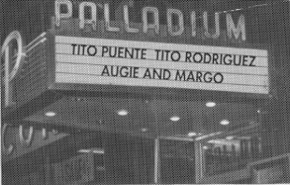

2) Image of unknown dancers inside the Palladium. Getty Images.

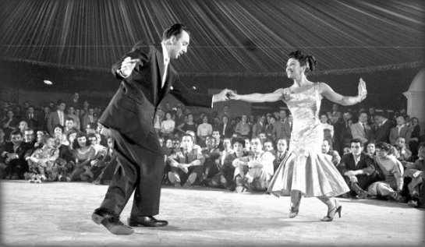

3) Image of Cuban Pete and Millie Donay dancing at the Palladium. The image first appeared in Life Magazine in 1954. It is now owned by Getty (<http://www.timelifepictures.com/source/search/FrameSet.aspx?s=AlternateImagesSearchState%7c0%7c3%7c-1%7c28%7c0%7c0%7c0%7c1%7c0%7c0%7c0%7c0%7c0%7c0%7c0%7c0%7c%7c286338%7c16384%7c0%7c0%7c0%7c0&tag=2>

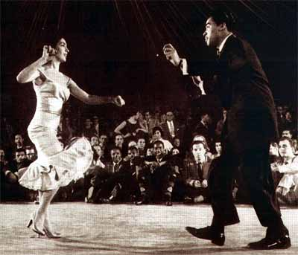

4) There are great images from this article 1953 issue of *Ebony Magazine* (vol. 9, issue 2, p. 40-48) A pdf of the entire article has been sent as a separate file.

**Websites**

palladium-mambo.com

1. This story about how the Palladium started featuring Latin music is repeated in every description of the ballroom, although every one can be traced back to two sources: Cesar Miguel Rondón, *The Book of Salsa: A Chronicle of Urban Music from the Caribbean to New York City*, translated by Frances Aparicio with Jackie White (Chapel Hill: University of North Carolina Press, 2008) and Max Salazar, *Mambo Kingdom: Latin Music in New York* (New York: Schirmer Trade Books, 2002). Both Rondón and Salazar tell a similar version of this story, but neither one cites his sources. No archival documents about the Blen Blen Club or this legendary dance have been located.
2. Richard J. H. Johnston, ‘13 Arrested Here in Ballroom Raid: Narcotics, Pistol and Razor Found Among the 800 Dancers at Palladium,’ *The New York Times*, April 9, 1961.